CE 641 Fate and Transport Modeling of Ecosystems

BOD/DO Modeling Using STREAM

Project 1

Determination of Assimilative Capacity of Walnut Creek near Troy, Alabama

Technical Report

Shibo Wang
SW5QC@VIRGINIA.EDU

October 3, 2007

BOD Wasteload Allocations for Walnut Creek
Introduction and Purpose
This case study and engineering practice focuses on the BOD wasteload allocations for Walnut Creek using the one-dimension model STREAM.
Since a review concerning the Walnut Creek wasteload conducted by Alabama Department of Environmental Management (ADEM) in 1993 found out that there were several technical issues which were not very reasonable. For example, in a simple but subtle case, the designated value of in-stream deoxygenation rate k_{d} was 0.56 day⁻¹(Lung.2001). However, the k_{d} value calculated by field data was 0.56 day⁻¹, which means extremely stringent effluent limit was put on the stream, making its assimilative capacity not be fully utilized. Therefore, at the request of Troy City, there is a need to develop a stream BOD/DO model using the STREAM code to estimate the allowable BOD load from the Troy wastewater treatment into Walnut Creek.
The Walnut Creek is divided into six reaches for sampling and modeling, shown as below,
2.85 mile
2.00 cfs
6.39 mile
1.5 cfs
7.13 mile
31.5 cfs

5.04 mile
2.40 cfs
Troy STP
1.2 mile
4.76cfs

X

0.0mile 6.14cfs
27.0°C
Walnut Creek
Fig.1 Walnut Flow
Data Analysis
The model must be well calibrated and verified with field data before making water management and wasteload allocation decision. Water quality data have been collected in two surveys which were conducted in August and October 1991 respectively, to calibrate and verify the DO model of Walnut Creek by ADEM.
Flow rate: 19.9 cfs Temperature: 27°C
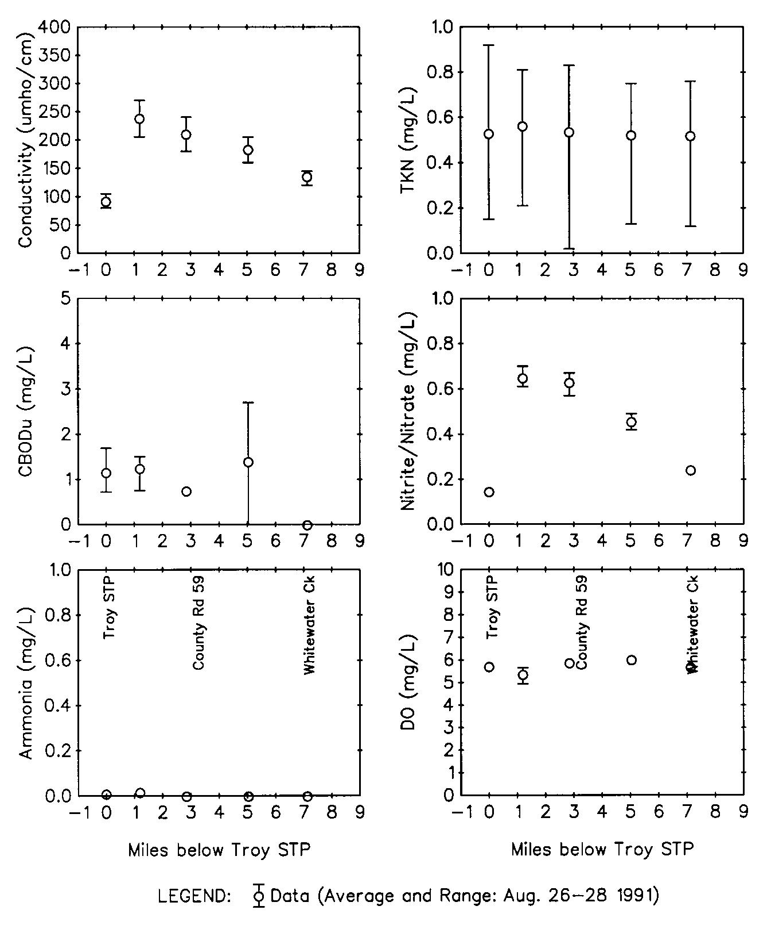
Fig.2 Field Data collected in Aug.1991(Walnut Creek Plots)
From Fig.2. it can be found that with the influx of Troy effluent, conductivity has got sharp instant increase, and with the tributaries come in, the conductivity gradually decrease. CBODu should also follow this trend. However, there is an abrupt increase at 5 miles downstream. The reason may be that certain organic compounds have been carried into the river. The amount of Ammonia is almost zero along the creek, indicating that due to relatively high temperature, the ammonia has volatized. The flux of TKN is very small and the DO is all above 5 mg/L.
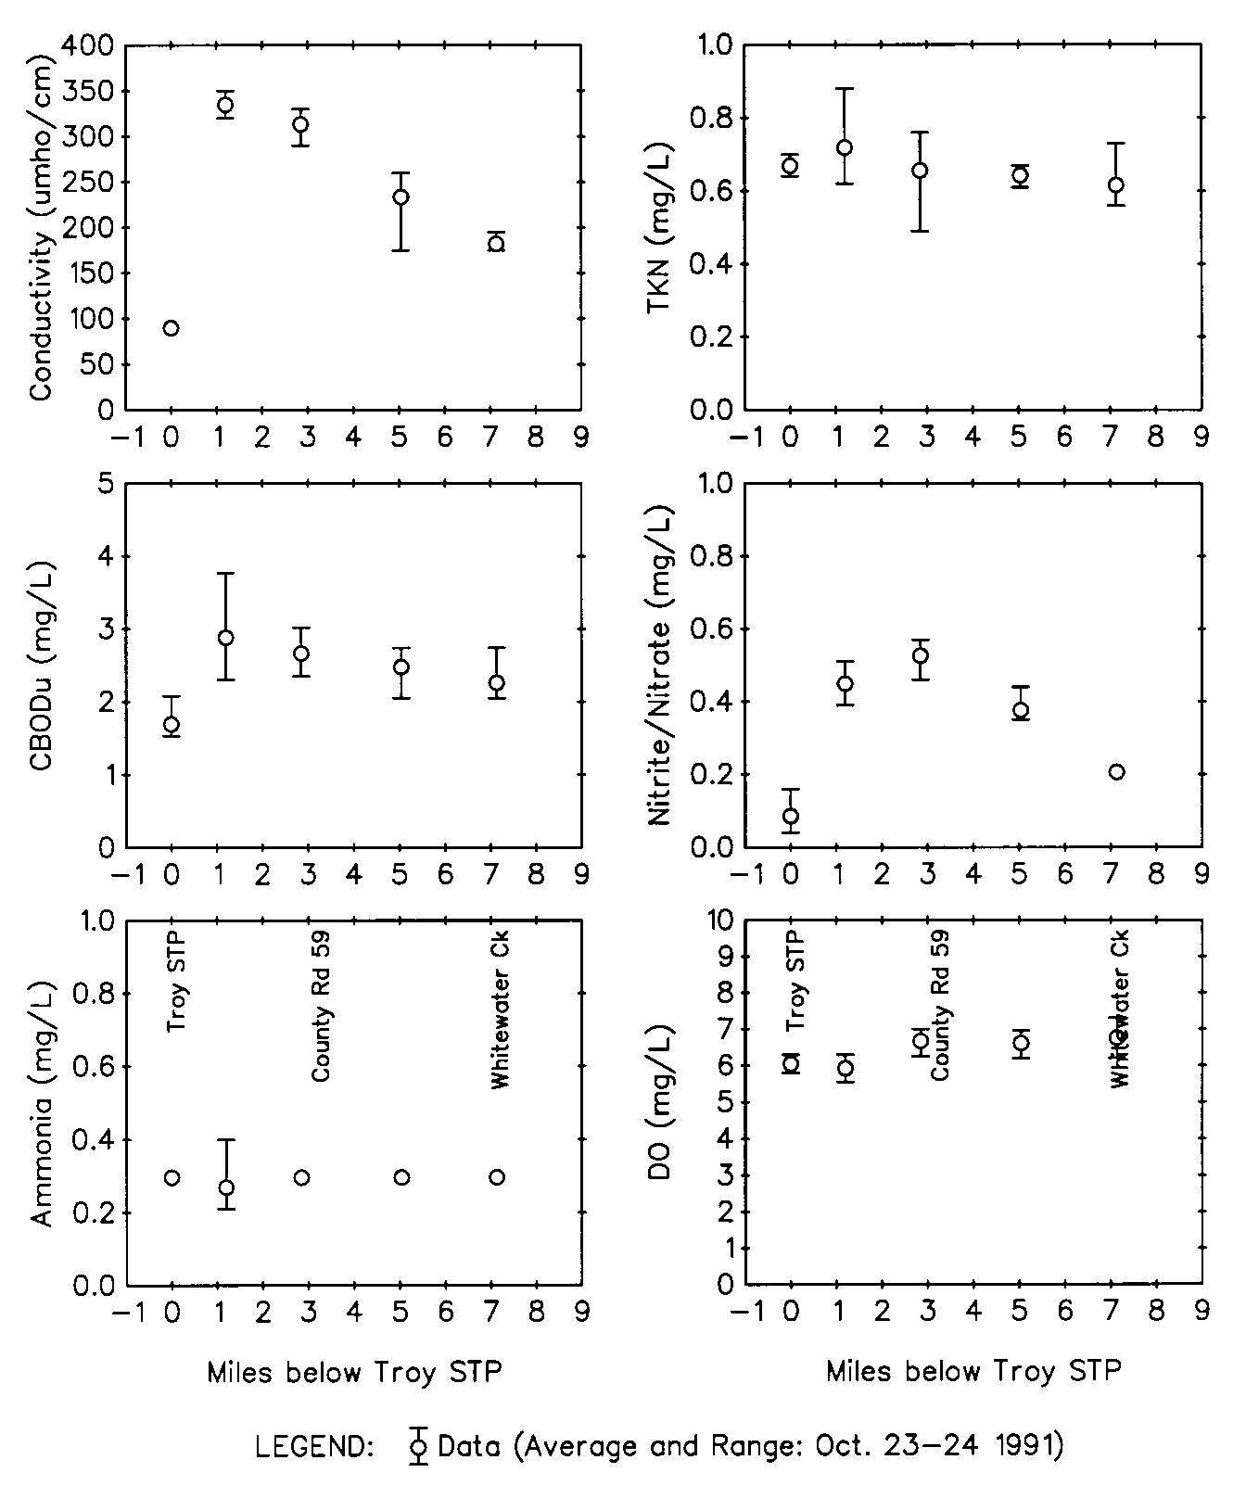
Fig.3 Field Data collected in Oct.1991(Walnut Creek Plots)
From Fig. 3, due to the lower flow rate and temperature, the change of conductivity is more apparent, ammonia concentration is steady. All DO values are above 5 mg/L, and are higher than the August condition. This phenomenon shows that under lower temperature, the solubility of oxygen is better.
Ultimate CBOD Data
The in-stream CBOD data are not adequate to derive the stream deoxygenation rate K_{d}, three independent analysis of samples from the Troy treatment plant and its ambient water column in upstream and downstream have been done (Lung.1998). Based on the data collected through April to June, 2004, the CBOD deoxygenation bottle rate K₁ can be calculated by first-order kinetic regression. The process of calculation is listed below (taking effluent for example)
It is assumed that the CBOD concentration obeys the first-order kinetics, therefore, the following relationship should exist (Analysis of BOD data):
dy/dt=K₁( L₀－L) Eq.1
where K₁ is CBOD bottle rate (day⁻¹) and L₀ is the ultimate CBOD (mg/L)
Integreaton of Eq.1 yields,
y= L₀ (1－e^{－K1t} ) Eq.2
There is certain deviation, in terms of R,
R= K₁ (L₀－y)－y’ Eq.3
where y’=dy/dt
Simplifying Eq.3 yields,
R=a+ by－y’ Eq.4
where a= K₁L₀ and K₁ =－b
In order to make the R² to be minimum, following set of equations should be satisfied:
na+bΣy－Σy’=0 Eq.5
aΣy+bΣy²－Σy’y=0 Eq.6
where n=number of data points
L₀=－a/b
y= any given CBOD value
y’=(y_{n+1}－y_{n－1})/2Δt
Therefore,
(1) for Troy effluent,
n=11; Σy=56.53; Σy²=365.131; Σy’y= 6.862; Σy’=1.914
11a+56.53b－1.914=0 Eq.7
56.53a+365.131b－6.862=0 Eq.8
Solve Eq.7 and Eq.8 a=0.3798 and b=－0.0399
L₀=9.52 mg/L and K₁=0.0399 day⁻¹
y= L₀ (1－e^{－K1t} )=9.52 (1－e^{－0.0399t} )
(2)for Troy upstream,
n=11; Σy=35.8; Σy²=130.299; Σy’y=2.347; Σy’=0.989
11a+35.8b－0.989=0 Eq.9
35.8a+130.299b－2.347=0 Eq.10
Solve Eq.9 and Eq.10 a=0.2969 and b=－0.0633
L₀= 4.69 mg/L and K₁= 0.0633 day⁻¹
y= L₀ (1－e^{－K1t} )=4.69 (1－e^{－0.0633t} )
(3)for Troy downstream,
n=11; Σy=41.27; Σy²=170.768; Σy’y= 2.723; Σy’=0.97
11a+41.27b－0.97=0 Eq.11
41.27a+170.768b－2.723=0 Eq.12
Solve Eq.11 and Eq.12 a=0.3048 and b=－0.0575
L₀=5.3 mg/L and K₁= 0.0575 day⁻¹
y= L₀ (1－e^{－K1t} )=5.3 (1－e^{－0.0575t} )
The data concerning y; y²; y’y and y’ are listed in Appendix One*.
In fact, the simplified calculation can be conducted and is also reasonable to represent the practical condition:
(1) for Troy effluent, y= L₀ (1－e^{－K1t} ), L₀=8.83 mg/L;
8 days, y₈=2.77, 2.77=8.83(1－e^{－8K1}) K₁=0.0578 day⁻¹
22 days, y₂₂=5.16, 5.16=8.83(1－e^{－22K1}) K₁=0.0399 day⁻¹
43 days, y₄₃=8.04, 8.04=8.83(1－e^{－43K1}) K₁=0.0781 day⁻¹
Therefore, estimate K₁=(0.0578+0.0399+0.0781)/3=0.0586 day⁻¹
(2) for Troy upstream, y= L₀ (1－e^{－K1t} ), L₀=4.78 mg/L;
8 days, y₈=2.25, 2.25=4.78(1－e^{－8K1}) K₁=0.0795 day⁻¹
22 days, y₂₂=3.08, 3.08=4.78(1－e^{－22K1}) K₁=0.0471 day⁻¹
43 days, y₄₃=4.42, 4.42=4.78(1－e^{－43K1}) K₁=0.0601 day⁻¹
Therefore, estimate K₁=(0.0795+0.0471+0.0601)/3=0.0622 day⁻¹
(3) for Troy downstream, y= L₀ (1－e^{－K1t} ), L₀=5.37 mg/L;
8 days, y₈=2.42, 2.42=5.37(1－e^{－8K1}) K₁=0.0749 day⁻¹
22 days, y₂₂=3.91, 3.91=5.37(1－e^{－22K1}) K₁=0.0592 day⁻¹
43 days, y₄₃=5.02, 5.02=5.37(1－e^{－43K1}) K₁=0.0635 day⁻¹
Therefore, estimate K₁=(0.0749+0.0592+0.0635)/3=0.0659 day⁻¹
From the results of CBOD bottle rate K₁, it can be found out that the order of K₁ is K_{1--downstream} > K_{1-- upstream} > K_{1—effluent}
However, the reasonable order should be
K_{1—effluent} > K_{1--downstream} > K_{1—upstream}
The reason for this may be due to the amount of CBOD in Troy effluent is so small that
the K₁ difference between the three condition is not obvious, i.e. the load is very low, or the
pollution is not potent.
Meanwhile, since the K₁ value is very small, it is reasonable enough to determine that K_{d} equals to K₁ under this situation (BOD/DO Kinetics).
The plots of CBOD concentration versus incubation time regarding three conditions are listed in Appendix One.

Modeling Approach
The STREAM model is a BOD and DO model for streams and rivers, which is based on the original work by O’Connor and his fellows at Manhattan College (Lung, 2001). The basic principle behind this model is mass balance, and the basic assumptions are steady-state conditions (dC/dt=0) and no flow gradient (dQ/dx=0). In this model, three water quality parameters are modeled, i.e. CBODu, NBOD, and DO (Lung.2001). However, in practice, the hydraulic geometry varies along the river or stream, so the STREAM model code is designed to accommodate many reaches in the one-dimensional configuration correspondingly. In each reach reach , mass balance must be maintained before starting a new one.
According to the rationale of mass balance, for a given reach of the stream, it is true that(BOD/DO Modeling)
Accumulation=Mass In－Mass Out+ Source－Sink
For CBODu, 0=－(Q/A)*(dL/dx)－KrL Eq.13
where L=CBODu; Kr= CBODu removal rate
For NBOD, 0=－(Q/A)*(dN/dx)－KnLN Eq.14
where N=NBOD concentration
For DO, 0= (Q/A)*(dC/dx)+ Ka(Cs－C)－K_{d}L－KnN +P－R－SOD/H Eq.15
where P=algal photosynthesis, R=algal respiration,
SOD/H= biological oxidation of sediment materials
Further, 0=－(Q/A)*(dD/dx)－KaD + K_{d}L + KnN－P + R + SOD/H Eq.16
where D= DO deficit
The solution to Eq.16 is:
D= (K_{d}L₀/Ka－Kr) (e^{－Krx/U}－e^{－Kax/U}) CBODu
+ (K_{n}N₀/Ka－Kn) (e^{－Knrx/U}－e^{－Kax/U}) NBOD
+ D₀ e^{－Kax/U} Initial Deficit
－(P/Ka) ( 1－e^{－Kax/U}) Algal Photosynthesis
+ (R/Ka) ( 1－e^{－Kax/U}) Algal Respiration
+ (SOD/HKa) ( 1－e^{－Kax/U}) SOD
where U= average stream velocity D₀= initial DO deficit
In the STREAM model, one of the key parameters, Ka, the reaeration coefficient, is related to the average stream velocity U and stream slope S, i.e. The Tsivoglou equation(Tsivoglou and Neal, 1976) (Lung.2001):
Ka (20°C)=CVS Eq.17
where C=propotional constant:
=1.8 for stream flow rate between 1 cfs and 10 cfs
=1.3 for stream flow rate between 10 cfs and 25 cfs
=0.88 for stream flow rate between 25 cfs and 300 cfs
Therefore, it is obvious that the bigger the flow rate is, the harder for oxygen reaeration.
Saturated DO concentration can be calculated by using the following equation(Lung and Sobeck.1999):
Cs=468/ (31.6 + T) Eq.18
where T= water temperature in °C
If CBODu is removed solely by direct oxidation (i.e. no sedimentation), the in-stream deoxygenation rate K_{d}, accounting for all the actual oxygen assumption in the stream, is equal to Kr, the CBODu removal rate coefficient.
Model Results
Mass Transport
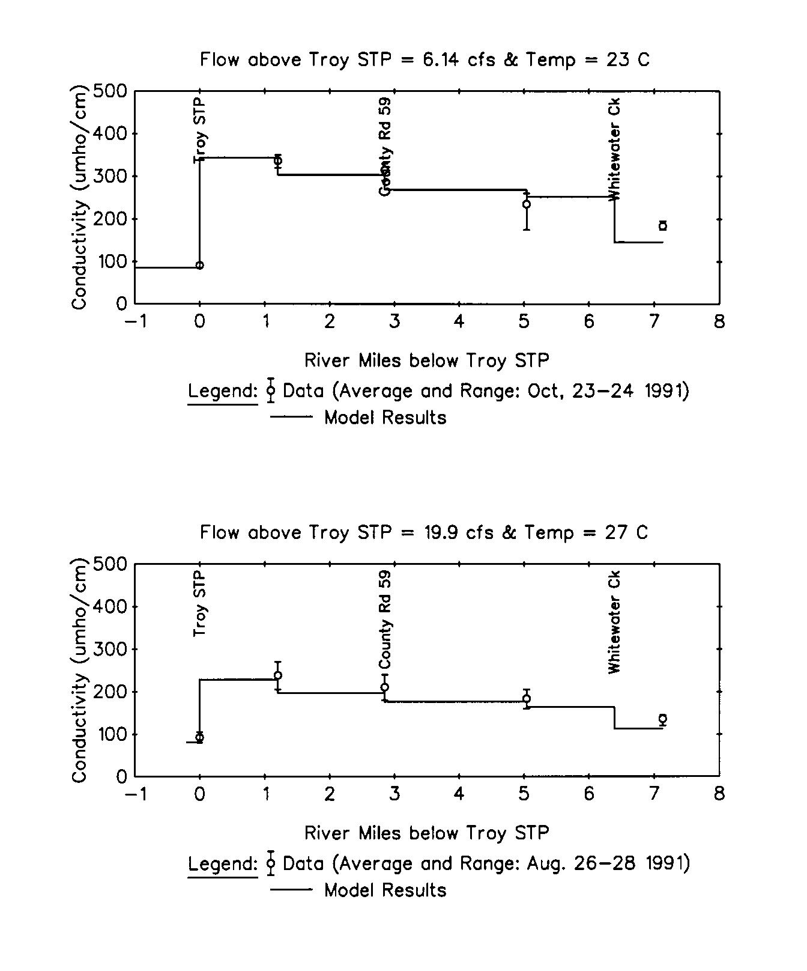
Fig.4. Conductivity of Walnut Creek in Aug and Oct 1991(Walnut Creek Plots)
The plots above are respectively the conductivity versus downstream distance plots measured in August and October 1991.Conductivity is the representative of the concentration of dissolved salts ions in stream, which are conservative, i.e. mass not changing with time. Therefore, the conductivity is used to track the in-stream mass transport. Due to the influx of Troy treatment plant, the conductivity shows sharp increase, indicating that there are a large amount of dissolved salts in the Troy discharge. In the October condition, owing to the smaller flow rate (6.14 cfs), the increase of conductivity is more apparent compared to that in August, 1991. Turn off the Kd value in the model, therefore, the trendlines are horizontal. The results of STREAM model fit well with the field data.
Time of Travel
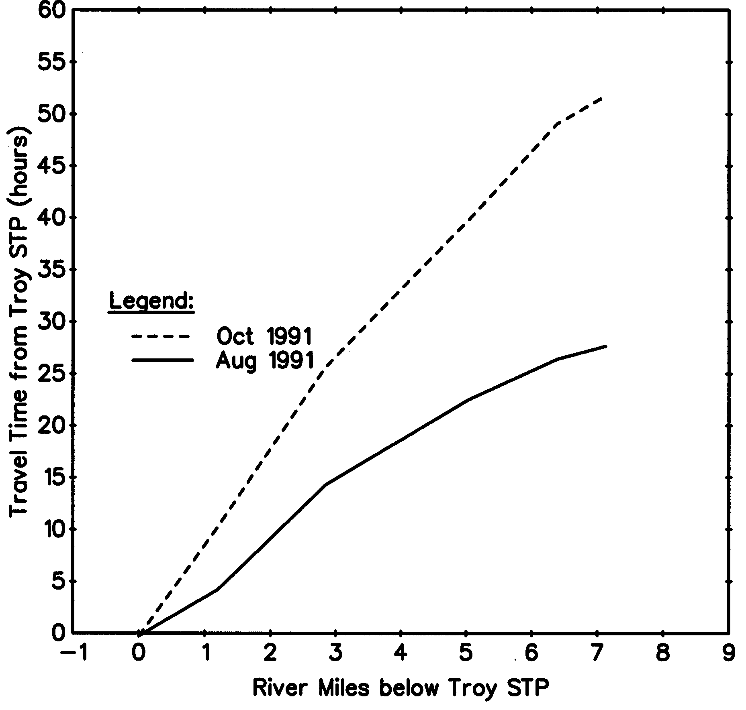
Fig.5. Travel time from Troy STP in Aug and Oct 1991(Walnut Creek Plots)
The plot above shows that the have different travel time in under different flow conditions. The condition in October takes longer time to travel, which indicates that under this low flow condition (flow rate=6.14cfs), the mass in-stream is not easy to disperse, hence the waste load in the water is relatively low. Since the retention time in each reach is relatively long, the model can be more sensitive under low flow rate situation.
CBOD, NBOD, DO Model Results
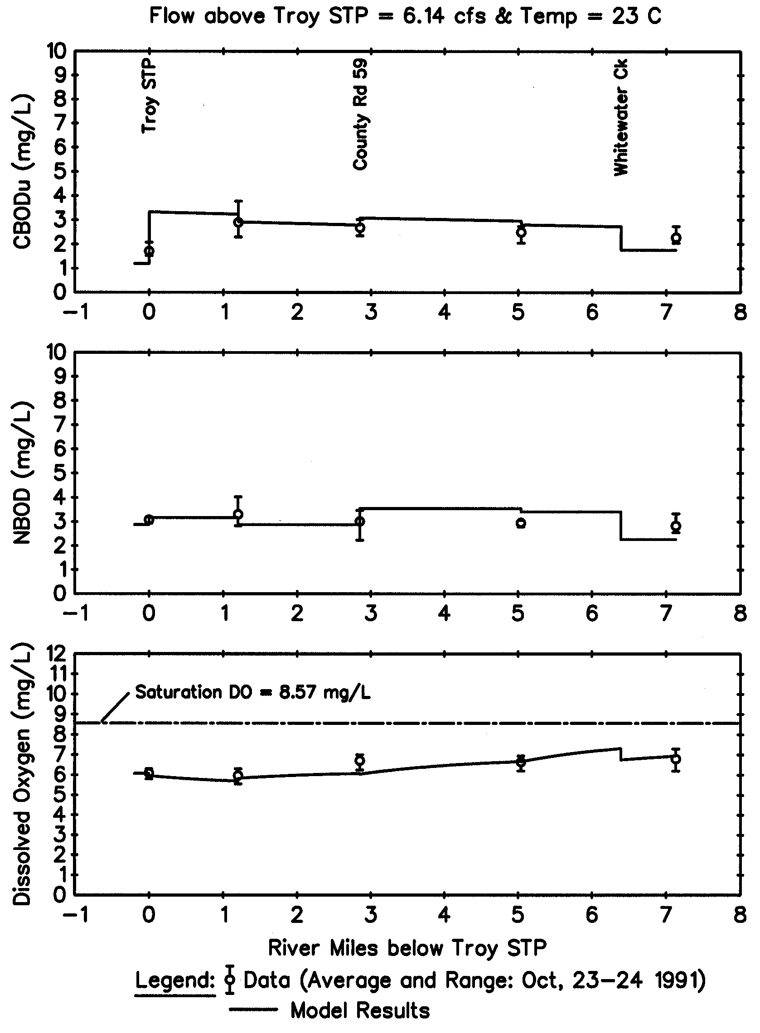
Load
Fig.6. CBODu, NBOD and DO results in Oct 1991(Walnut Creek Plots)
According to Saturated Oxygen Concentration Cs=468/(31.6+ T), it can be find out that when T increases, the Cs will decrease. DO values are all above 5 mg/L, the room represents the assimilative capacity of the stream in terms of BOD load. The model results fit the field data well. Therefore, the STREAM model is well-calibrated.
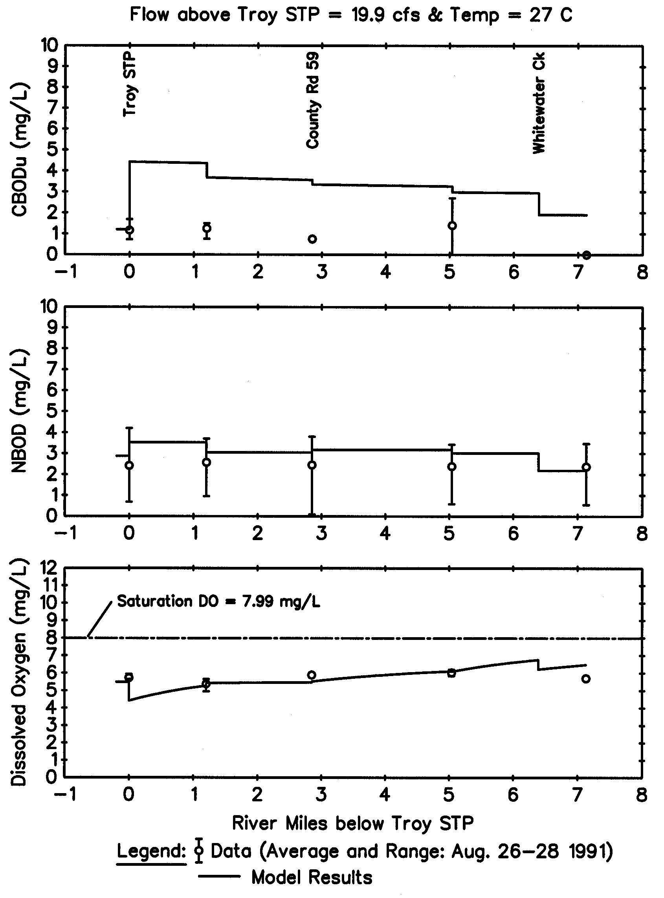
Fig.7. CBODu, NBOD and DO results in Aug 1991(Walnut Creek Plots)
Sometimes, the DO values are below 5 mg/L. The reason can be explained as the influx of Troy discharge, which has low DO concentration, causes the overall deficiency of DO. Also, the high temperature making the solubility of oxygen in water decrease contributes to the low DO.
According to the following equation: K_{T}=K_{20°C}θ^{T-20} (BOD/DO Kinetics),
where θ ranges from 1.047~1.088
the high temperature can also make the model sensitive. However, its influence is not greater than that caused by low flow rate.

Wasteloads Allocations
The ambient environmental conditions are as fellow:
the flow rate of Walnut Creek above the Troy wastewater treatment plant: 6.14 cfs,
and ,water temperature: 27°C. Under this condition, model are relatively more sensitive.
Water quality requirement:
DO below the Troy wastewater treatment plant discharge >5 mg/L
DO level in the effluent of Troy STP
DOD in Troy effluent is 19.2 Ib/day which is equal to 19.2/(4.76 cfs * 5.4)=0.747mg/L
Cs=468/(31.5+T)= 468/(31.5+ 27)=8 mg/L
Therefore, DO in effluent= Cs－DOD=8－0.747=7.253 mg/L
Using STREAM model, vary the in-stream deoxygenation rate K_{d}= K_{r} (shown as XXXX in the input file) from 0.05 day⁻¹ to 0.30 day⁻¹, and vary the CBODu load L₀ (shown as XXXXX in the input file) at the same time, making sure that the DO is above or near 5 mg/L. Data input are listed in Appendix Two.
After a several time of model runs, the combination of CBODu load and K_{d} have been found and the data are listed below:
CBODu(lds/day) | 965 | 605 | 395 | 310 | 255 | 205 | 170 | 155 | 145
K_{d}(day⁻¹) | 0.05 | 0.08 | 0.12 | 0.15 | 0.18 | 0.22 | 0.26 | 0.28 | 0.30
Since the CBOD load calculated by STREAM is ultimate CBOD, which is not convenient for the practical operating for the Troy wastewater treatment plant, it is necessary to convert CBODu into CBOD₅. Due to the existing relationship between CBODu and CBOD₅, i.e.
CBODu/CBOD₅=1/(1－e^{－5K1}) (BOD/DO Kinetics) Eq.19
Therefore, CBOD₅= CBODu (1－e^{－5K1}) Eq.20
Take K_{d}= 0.05 day⁻¹ for example to illustrate the calculation of CBOD₅
CBOD₅=965 (1－e^{－5*0.05}) =213.46 Ibs/day
Correspondingly, the final CBOD₅ loading rates (Ibs/day) of varing K_{d} have been listed below:
CBOD₅(lds/day) | 213.46 | 199.47 | 178.22 | 163.56 | 151.32 | 136.76 | 123.68 | 116.78 | 112.65
CBODu(lds/day) | 965 | 605 | 395 | 310 | 255 | 205 | 170 | 155 | 145
K_{d}(day⁻¹) | 0.05 | 0.08 | 0.12 | 0.15 | 0.18 | 0.22 | 0.26 | 0.28 | 0.30

Plot CBOD₅ loading rate versus K_{d}
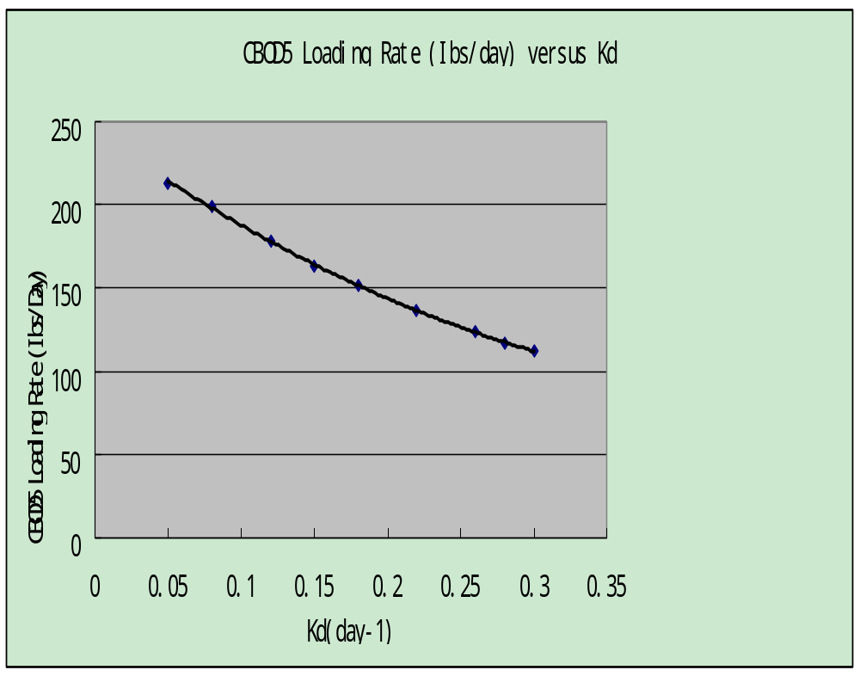

Summary and Conclusions
After a series of work concerning the data analysis, the tracking of mass transport, the verification and calibration of STREAM model, and the wasteload allocation decision of the Troy STP into the Walnut Creek, it can be clearly included as felow:
- The STREAM model is well-calibrated by using the data collected in Aug and Oct 1991.
- The deoxygenation coefficients calculated by using the ultimate BOD data of the effluent from Troy STP, upstream and downstream as of May, 2004 are 0.0399day⁻¹, 0.0633 day⁻¹ and 0.0575 day⁻¹ respectively. These values are far smaller than the originally designated value of in-stream deoxygenation rate of 0.56 day⁻¹, demonstrating that the original wasteload is too stringent.
- The DO level in the effluent of Troy STP is 7.253 mg/L
- Following the requirement that DO should be above 5 mg/L in the water column, wasteload allocations under different conditions concerning CBOD₅ are acquired by varing the in-stream deoxygenation rate K_{d} from 0.05 day⁻¹ to 0.30 day⁻¹. The results have been ploted.
- During analysis of the data, it is found that under relatively low flow rate and high temperature conditions, the STREAM model can be more sensitive and can have better performance.
(6) It is believed that given more field data, the model can fit and simulate better to the
actual conditions.

Literature Cited

Lung,W.S.(2001). Water Quality Modeling For Wasteload Allocations and TMDLs, John Wisley & Sons, New York, NY.

Anonymous report(1991). Walnut Creek Plots

Anonymous report(1991). BOD/DO Modeling Using STREAM

Anonymous report. BOD/DO Kinetics

Anonymous report. Analysis of BOD data to Determine the Kinetic Coefficients

Lung,W.S.(1998). Trends in BOD/DO Modeling for Wasteload Allocations Journal of Environmental Engineering, October, 1998

Lung,W.S. and Sobeck, R.G. (1999). Renewed Use of BOD/DO Models in Water Quality Management, Journal of Watre Resourses Planning and Management, July/August 1999

Appendix One : Ultimate CBOD data
(1) Troy effluent
Table 1. Troy Effluent
y | y2 | y' | y'y
0 | 0
1.21 | 1.4641 | 0.365 | 0.44165
2.19 | 4.7961 | 0.2775 | 0.607725
2.32 | 5.3824 | 0.29 | 0.6728
2.77 | 7.6729 | 0.2725 | 0.754825
4.5 | 20.25 | 0.170714 | 0.768214
5.16 | 26.6256 | 0.104286 | 0.538114
5.96 | 35.5216 | 0.165 | 0.9834
7.47 | 55.8009 | 0.148571 | 1.109829
8.04 | 64.6416 | 0.068571 | 0.551314
8.43 | 71.0649 | 0.031429 | 0.264943
8.48 | 71.9104 | 0.02 | 0.1696
8.83 | 77.9689
56.53 | 365.1305 | 1.913571 | 6.862414

(2) Troy upstream

Table 2. Troy Upstream
y | y2 | y' | y'y
0 | 0
1.36 | 1.8496 | 0.375 | 0.51
2.25 | 5.0625 | 0.195 | 0.43875
2.14 | 4.5796 | 0 | 0
2.25 | 5.0625 | 0.11625 | 0.261563
3.07 | 9.4249 | 0.059286 | 0.182007
3.08 | 9.4864 | 0.032857 | 0.1012
3.53 | 12.4609 | 0.075714 | 0.267271
4.14 | 17.1396 | 0.063571 | 0.263186
4.42 | 19.5364 | 0.045714 | 0.202057
4.78 | 22.8484 | 0.025714 | 0.122914
4.78 | 22.8484 | -0.0005 | -0.00239
4.77 | 22.7529
35.8 | 130.2992 | 0.988607 | 2.346558

(3) Troy Downstream

Table 3. Troy Downstream
y | y2 | y' | y'y
0 | 0
1.88 | 3.5344 | 0.421667 | 0.792733
2.53 | 6.4009 | 0.13 | 0.3289
2.4 | 5.76 | -0.055 | -0.132
2.42 | 5.8564 | 0.14375 | 0.347875
3.55 | 12.6025 | 0.106429 | 0.377821
3.91 | 15.2881 | 0.060714 | 0.237393
4.4 | 19.36 | 0.059286 | 0.260857
4.74 | 22.4676 | 0.044286 | 0.209914
5.02 | 25.2004 | 0.028571 | 0.143429
5.14 | 26.4196 | 0.018571 | 0.095457
5.28 | 27.8784 | 0.0115 | 0.06072
5.37 | 28.8369
41.27 | 170.7683 | 0.969774 | 2.7231
Plot CBOD concentration versus incubation time: determine K₁→K_{d}
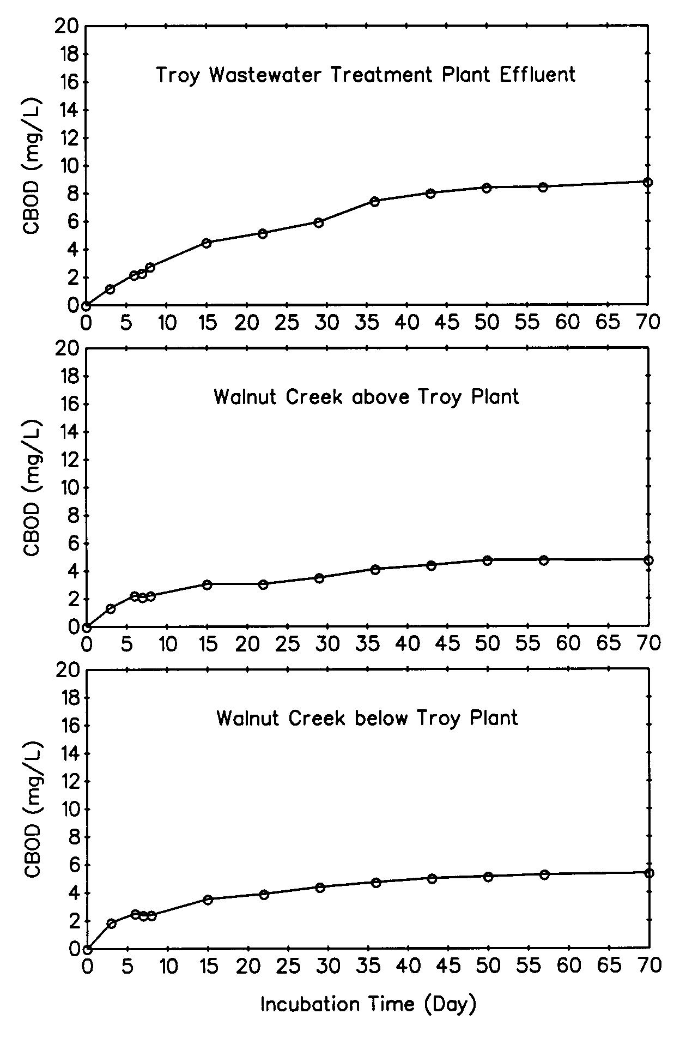
(Walnut Creek Plots)
Appendix Two: Input Data File

Wasteload Allocation Model for Walnut Creek, Alabama October 1991 Hydraulic Geometry

6.0 -0.2 0.10 1.00

1.20 0.0 2.876 0.0 2.50 0.0 0.0 0.0 0.001

6.14 0.5 35.9 27.0 0.0 0.0 0.0 0.0

0.0 CBODu 0.0 39.7 0.00 19.2 1.0 0.0 10.83

4.76 0.50 65.3 27.0 1.2 K_{d} K_{d} 0.0

1.2 0.0 1.3 0.0 2.0 0.0 1.0 0.0 9.70

2.00 0.75 82.5 27.0 2.85 K_{d} K_{d} 0.0

1.2 44.4 2.00 66.6 2.0 9.1 1.0 0.0 7.30

2.40 1.00 67.4 27.0 5.04 K_{d} K_{d} 0.0

1.2 0.0 2.00 0.0 2.0 0.0 1.0 0.0 8.15

1.5 2.0 78.9 27.0 6.39 K_{d} K_{d} 0.0

1.26 0.0 1.67 0.0 2.11 0.0 1.0 0.0 4.05

31.5 4.50 120.0 27.0 7.13 K_{d} K_{d} 0.0

